**Working with File Contents**

**Files**

A simple description of the UNIX system, also applicable to Linux, is this: “On a UNIX system, everything is a file; if something is not a file, it is a process.”

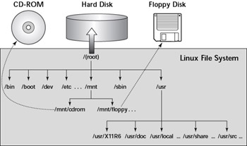

A Linux system, just like UNIX, makes no difference between a file and a directory, since a directory is just a file containing names of other files. Programs, services, texts, images, and so forth, are all files. Input and output devices, and generally all devices, are considered to be files, according to the system.

A directory is a special kind of file, but it is still a (case sensitive!) file. Each terminal window (for example /dev/pts/4), any hard disk or partition (for example /dev/sdb1) and any process are all represented somewhere in the file system as a file. It will become clear throughout this course that everything on Linux is a file.

The tree of the file system starts at the trunk or slash, indicated by a forward slash (/). This directory, containing all underlying directories and files, is also called the root directory or “the root” of the file system.

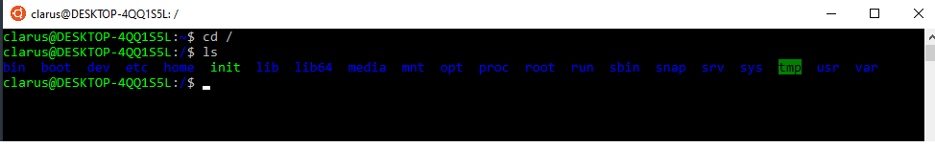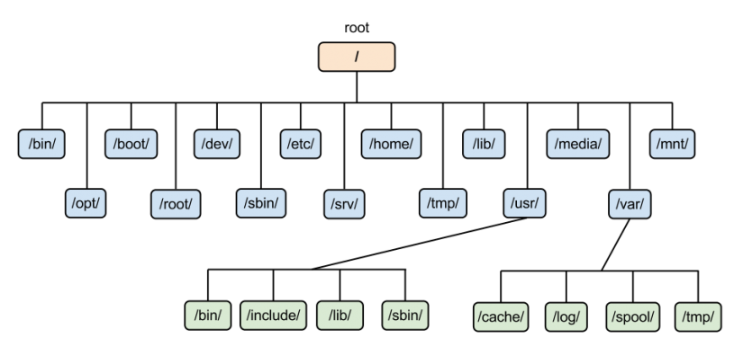

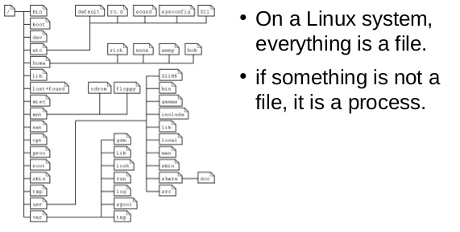

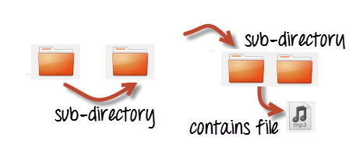

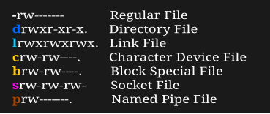

* This table gives an overview of the characters determining the file type:

| **Symbol** | **Meaning** |
| --- | --- |
| - | Regular file |
| d | Directory |
| l | Link |
| c | Special file |
| s | socket |
| p | Named pipe |
| b | Block device |

**Viewing file properties**

**ls** command Displays a list of files in the current working directory. Besides the name of the file, ls can give a lot of other information, such as the file type. It can also show *permissions* on a file, *file size*, *inode number*, *creation date* and *time*, *owners* and *amount of links* to the file. With the -a option to ls, files that are normally hidden from view can be displayed as well. These are files that have a name starting with a *dot*.

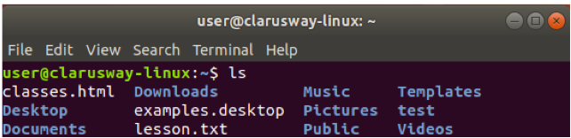

* Directories are denoted in blue color.
* Files are denoted in white
* You will find similar color schemes in different flavors of Linux

**💡Tips:**

On most Linux versions ls is aliased to color-ls by default. This feature allows to see the file type without using any options to ls. To achieve this, every file type has its own color. The standard scheme is in /etc/DIR_COLORS:

Color_File Type

* blue _directories
* red_compressed archives
* white_text files
* pink_ images
* cyan _links
* yellow_devices
* green_executables
* flashing red_broken links

You should read the Info pages about ls since it is a very common command with a lot of useful options. Options can be combined. A common combination is ls -al; it shows a long list of files and their properties.

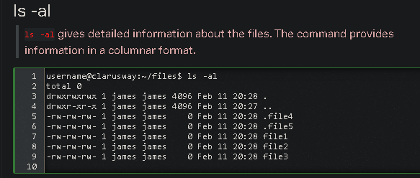

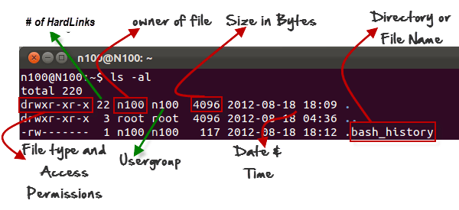

**Working with File Contents-1**

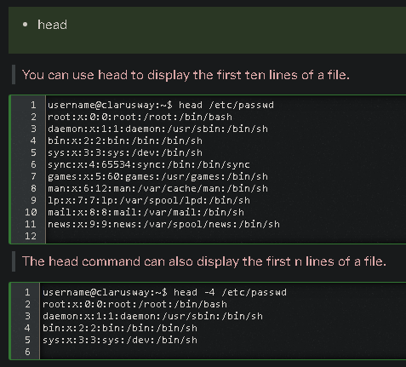

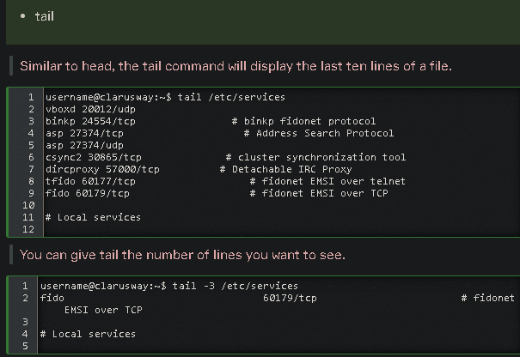

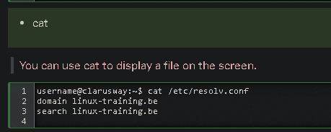

**Q:** How do you display the contents of a file in Linux terminal?  
**A:** **Cat** is most commonly used to display the contents of one or multiple text files, combine files by appending the contents of one file to the end of another file, and create new files.

 - Interview Q&A

**Working with File Contents-2**

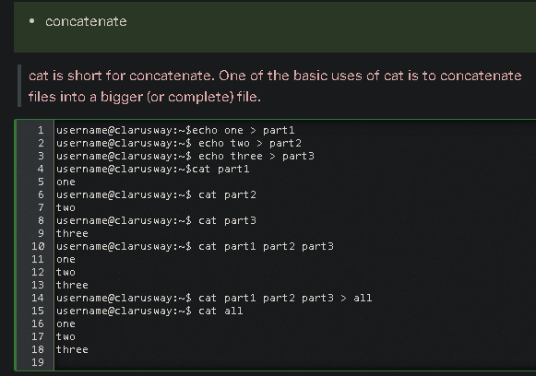

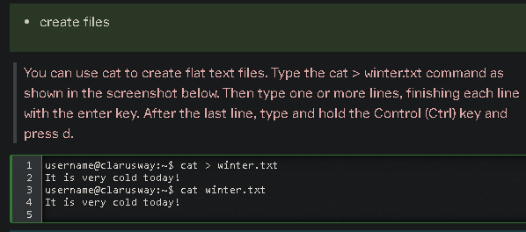

**💡Tips:**

The Ctrl d key combination will send an EOF (End of File) to the running process ending the cat command.

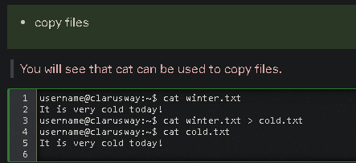

**Working with File Contents-3**

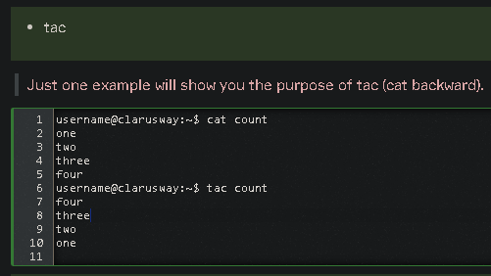

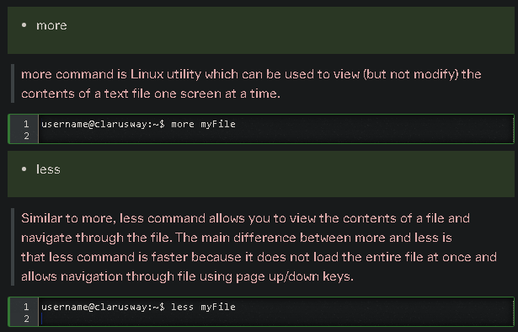

**Searching Files (find Command)**

find Command

The “find” command allows you to search for files for which you know the approximate filenames. The simplest form of the command searches for files in the current directory and recursively through its subdirectories that match the supplied search criteria.

**💡Tips:**

FIND is an command for searching file(s) and folder(s) using filters such as size , access time , modification time.

Typing the following command at the prompt lists all files found in the current directory.

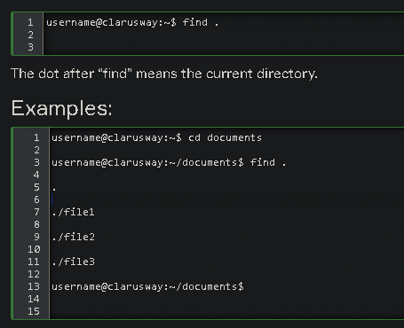

Use the -name argument to find files that fit a specific pattern.

For example, if we want to find all the files that start with “fil” in the /home directory, we type the following command.

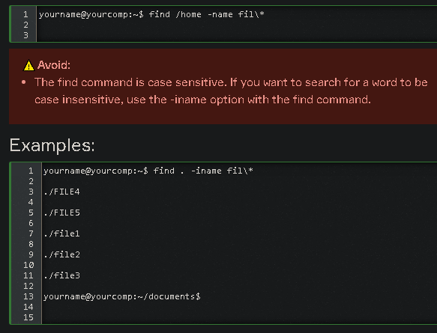

**Searching Files (grep Command)**

**grep Command**

The grep, which stands for "global regular expression print," is used to search text. It searches the given file for lines containing a match to the given strings or words.

**💡Tips:**

GREP :(Globally search a Regular Expression and Print).

The syntax:

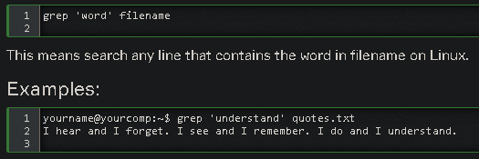

**💡Tips:**

The Major difference is FIND is for searching files and directories using filters while GREP is for searching a pattern inside a file or searching process(es)

| **Command** | **Description** |
| --- | --- |
| grep -i | Returns the results for case insensitive strings |
| grep -n | Returns the matching strings along with their line number |
| grep -v | Returns the result of lines not matching the search string |
| grep -c | Returns the number of lines in which the results matched the search string |

**Q:** Why the **grep** command used for?  
**A:** The grep command is used to search text. It searches the given file for lines containing a match to the given strings or words. It is one of the most useful commands on Linux and Unix-like system.

 - Interview Q&A

Complementary Lesson about File System :

<https://youtu.be/HbgzrKJvDRw>

Complementary Lesson about Searching Files :

<https://youtu.be/xxeEwV5kNXA>